Battery Management System (BMS) Requirements – Extended with SOC & SOH
1. Purpose
The BMS shall safely control HV contactors, monitor key electrical/thermal parameters, estimate battery status (SOC, SOH, cycles), and protect the system through fault detection and state-based logic.

2. Key Parameters
The BMS shall monitor and/or compute:
- Battery-side Voltage (V_batt) – battery pack terminal voltage.
- Bus-side Voltage (V_bus) – load/motor side voltage.
- Pack Current (I_pack) – charging/discharging current.
- Pack Temperature (T_pack) – battery temperature(s).
- Contactor Feedback – status confirmation of precharge and main contactors.
- SOC (State of Charge) – remaining battery capacity in %.
- SOH (State of Health) – available capacity relative to new, in %.
- Cycle Count – number of charge–discharge cycles completed.

3. Operating States
- OFF: Key switch OFF or system fault exit. All contactors open.
- WAIT: Key switch ON, pre-checks, all contactors open.
- PRECHARGE: Precharge sequence in progress. Precharge contactor closed until |V_batt – V_bus| ≤ 3V (within timeout).
- HV: Main contactors closed, HV active on bus. Precharge contactor open.
- FAULT: Any unsafe condition. Contactors opened immediately, logged.

4. Functional Requirements
4.1 HV Bus Connection / Disconnection
- ON → OFF: All contactors shall open, state = OFF.
- OFF → ON: Transition through WAIT → PRECHARGE → HV if no fault.
- PRECHARGE success = |V_batt – V_bus| ≤ 3V.
- PRECHARGE timeout or failure = FAULT.

4.2 Monitoring & Fault Handling
The BMS shall continuously detect:
- Voltage faults: V_batt < V_min or > V_max.
- Current faults: |I_pack| > I_limit.
- Temperature faults: T_pack < T_min or > T_max.
- Contactor faults: Command ≠ feedback.
On fault:
- Open all contactors immediately.
- Transition to FAULT state.
- Log fault event to NVM.

4.3 SOC Estimation
- SOC shall be computed in real time using Coulomb counting corrected with OCV (Open Circuit Voltage) when pack is at rest.
- SOC shall update at least once per second.
- SOC shall be clamped to [0%, 100%].
- At system start:
  - If pack at rest → initialize SOC from OCV vs. SOC lookup table.
  - Else → initialize SOC from last stored SOC value in NVM.

4.4 SOH Estimation
- SOH shall be estimated based on observed usable capacity relative to rated capacity (SOH% = Measured_Capacity / Nominal_Capacity × 100).
- The BMS shall accumulate charge/discharge cycles:
  - One full cycle = equivalent of 100% discharge.
  - Partial cycles shall accumulate (e.g., 2 × 50% discharges = 1 cycle).
- SOH shall be updated after each completed cycle or during periodic maintenance checks.
- SOH thresholds:
  - SOH_warn (e.g., 80%) → log warning.
  - SOH_critical (e.g., 70%) → log warning and optionally limit discharge current.

4.5 Non-Volatile Storage (NVM)
The BMS shall store the following values in non-volatile memory to persist across power cycles:
- Last known SOC.
- Current SOH estimate.
- Total cycle count.
- Fault history / last fault code.
Stored values must be updated reliably with minimal wear (e.g., EEPROM write protection or periodic batch updates).

5. State Transition Rules
- OFF → WAIT: Key switch ON, no fault.
- WAIT → PRECHARGE: HV connect command received.
- PRECHARGE → HV: |V_batt – V_bus| ≤ 3V within timeout.
- ANY STATE → FAULT: Fault detected.
- FAULT → OFF: Key switch OFF.
- FAULT → WAIT: Key switch OFF → ON + fault cleared.
- HV → OFF: Key switch OFF or fault detected.

6. Verification
- Key switch ON/OFF transition tests.
- Precharge success/failure timing tests.
- Voltage/current/temperature fault injection.
- SOC accuracy validated against lab discharge test (≤ ±5% error).
- SOH accuracy validated against measured cycle capacity (≤ ±10% error).
- Confirm SOC, SOH, and cycle count persist after reset (NVM write/read test).

✅ With this addition, your BMS requirements now cover:
- Contactor & state logic
- Fault handling
- SOC/SOH estimation
- Cycle count accumulation
- NVM persistence

Req ID | Description | Inputs | Outputs | Acceptance Criteria
BMS-001 | BMS shall remain in OFF state when key switch is OFF. | Key switch = OFF | All contactors open, state = OFF | Verified in test: contactors are open, no HV present on bus.
BMS-002 | On key switch ON, BMS shall transition to WAIT state and perform system checks. | Key switch = ON | State = WAIT | System enters WAIT state, no contactors closed.
BMS-003 | BMS shall enter PRECHARGE state on HV bus connect command. | HV bus connect cmd = ON | Precharge contactor closed | Verified by observing precharge contactor feedback.
BMS-004 | During precharge, BMS shall close main contactors once | V_batt – V_bus | ≤ 3V (within timeout). | V_batt, V_bus
BMS-005 | After successful precharge, BMS shall open precharge negative contactor. | Contactor command | Precharge negative = open | Verified by feedback.
BMS-006 | On any fault condition, BMS shall open all contactors and enter FAULT state. | V_batt, I_pack, T_pack, contactor feedback | All contactors open, State = FAULT | Fault injected → contactors open within 100 ms.
BMS-007 | BMS shall monitor for over-voltage. | V_batt | Fault flag, FAULT state | Trigger when V_batt > V_max.
BMS-008 | BMS shall monitor for under-voltage. | V_batt | Fault flag, FAULT state | Trigger when V_batt < V_min.
BMS-009 | BMS shall monitor for over-current. | I_pack | Fault flag, FAULT state | Trigger when
BMS-010 | BMS shall monitor for over- and under-temperature. | T_pack | Fault flag, FAULT state | Trigger when T_pack < T_min or > T_max.
BMS-011 | BMS shall detect contactor feedback mismatch. | Contactor cmd, feedback | Fault flag, FAULT state | Fault when feedback ≠ cmd within timeout.
BMS-012 | BMS shall compute SOC in real time. | V_batt, I_pack, T_pack | SOC% | SOC updated at ≥1 Hz.
BMS-013 | At startup, SOC shall be initialized using OCV if pack at rest, else from last stored SOC in NVM. | Key switch, V_batt, I_pack | SOC_init% | Verified by rest/no-rest startup conditions.
BMS-014 | SOC shall be corrected using OCV when pack current ≤ I_rest_threshold for ≥ t_ocv_window. | V_batt, I_pack, T_pack | SOC_corrected% | OCV-based correction applied within tolerance.
BMS-015 | BMS shall compute SOH based on usable capacity relative to nominal capacity. | I_pack, cycle data | SOH% | SOH updated at least once per full cycle.
BMS-016 | BMS shall accumulate charge–discharge cycles (partial cycles allowed). | I_pack | cycle_count | cycle_count increments when cumulative ΔAh = 100% capacity.
BMS-017 | BMS shall log and store SOC, SOH, and cycle count in NVM. | SOC, SOH, cycle_count | Stored values | Values persist after reset.
BMS-018 | On key switch OFF, BMS shall open all contactors and enter OFF state. | Key switch = OFF | State = OFF | Verified by state transition to OFF.
BMS-019 | BMS shall allow FAULT recovery only when key switch is toggled OFF → ON and fault is cleared. | Key switch, fault status | State = WAIT | Verified by fault injection & recovery.

Battery Design: Cell Volt 3.2V, 100Ah
`
Load
CMU
Cell10 +
Cell12 +
Cell10 -
Cell9 +
Cell11 +
Cell12 -
Cell11 -
Cell9 -
CMU
Cell5 -
Cell6 +
Cell7 -
Cell5 +
Cell6 -
Cell7 +
Cell8 -
Cell8 +
CMU
Cell2 +
Cell3 -
Cell4 +
Cell4 -
Cell2 -
Cell3 +
Cell1 -
Cell1 +
ISO SPI Secondary
ISO SPI Primary

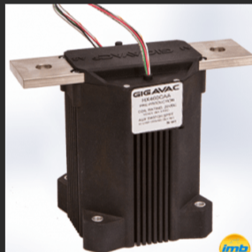
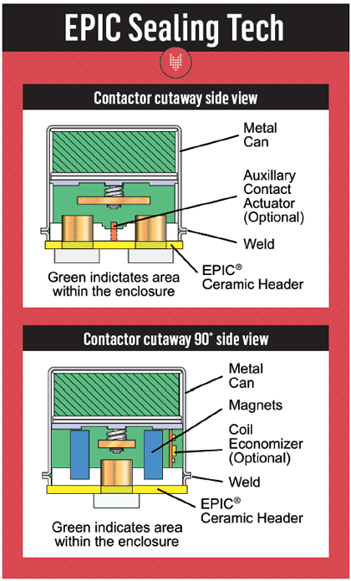
Contactor Monitoring:
Normally Open state.
Close state :
Stuck open : If contcator is requested to close but contactor didn’t close based on feedback
Stuck closed : If contcator is requested to open but contactor didn’t open on feedback
Contactor should be closed when there are no faults and HV connect command is received.

Battery Design: Cell Volt 3.2V, 100Ah
`
Load
CMU
Cell10 +
Cell12 +
Cell10 -
Cell9 +
Cell11 +
Cell12 -
Cell11 -
Cell9 -
CMU
Cell5 -
Cell6 +
Cell7 -
Cell5 +
Cell6 -
Cell7 +
Cell8 -
Cell8 +
CMU
Cell2 +
Cell3 -
Cell4 +
Cell4 -
Cell2 -
Cell3 +
Cell1 -
Cell1 +

ISO SPI Secondary
ISO SPI Primary

